# COMP1562, Lab #7 Memory placement algorithms

|  |  |  |  |
| --- | --- | --- | --- |
| Lecturer | **Mariusz Pelc** | Phone | **020 83318588** |
| Office | **QM366** | e-mail address | [**m.pelc@gre.ac.uk**](mailto:m.pelc@gre.ac.uk) |
| Office hours | **Mon 4-5pm, Wed 9-10pm** |  |  |

**(by M. Pelc and K. McManus)**

**Description:**

**This exercise is mainly focused on memory placement algorithms.**

**Learning Outcomes:**

**Students will be able to understand differences between various memory placement algorithms.**

**TASKS**

1. **Solve the following two tasks and check the results with scriptcheck system.**
   1. **Scenario 1**

At a given time there are the following gaps in the memory allocation (in memory order):

*M1=9k* ***M2=13k******M3=52k M4=18k*** *M5=15k*

***FIRST***

***P1-M3,P2-M2,P3-M4,P4-M1,*P5-M5**

BEST

**P1-M3,P2-M2,P3-M5,P4-M1,P5-M4**

**WORST**

**P1-M3,P2-M4,P3-M5,P4-M2,P5-M1**

NEXT

**P1-M3,P2-M4,P3-M5,P4-M1,P5-M2**

The next process requests P1=36k of memory and is allocated to the M3 gap (52k).

Show the memory allocation after the next four successive process requests of P2=12k P3=10k, P4=3k and P5=8k using each of the four placement algorithms; **first** fit, **best** fit, **next** fit and **worst** fit.

* 1. **Scenario 2**

At a given time there are the following gaps in the memory allocation (in memory order):

***M1=9k***  *M2=13k* ***M3=52k*** *M4=18k* ***M5=15k***

The next process requests P1=36k of memory and is allocated to the M3 gap (52k).

Show the memory allocation after the next four successive process requests of P2=15k P3=3k, P4=10k and P5=8k using each of the four placement algorithms; **first** fit, **best** fit, **next** fit and **worst** fit.

**FIRST**

**P1-M3,P2-M4,P3-M1,P4-M2,P5-M5**

BEST

**P1-M3,P2-M5,P3-M1,P4-M2,P5-M4**

**NEXT**

**P1-M3,P2-M4,P3-M5,P4-M2,P5-M1**

**WORST**

**P1-M3,P2-M4,P3-M5,P4-M2,P5-M1**

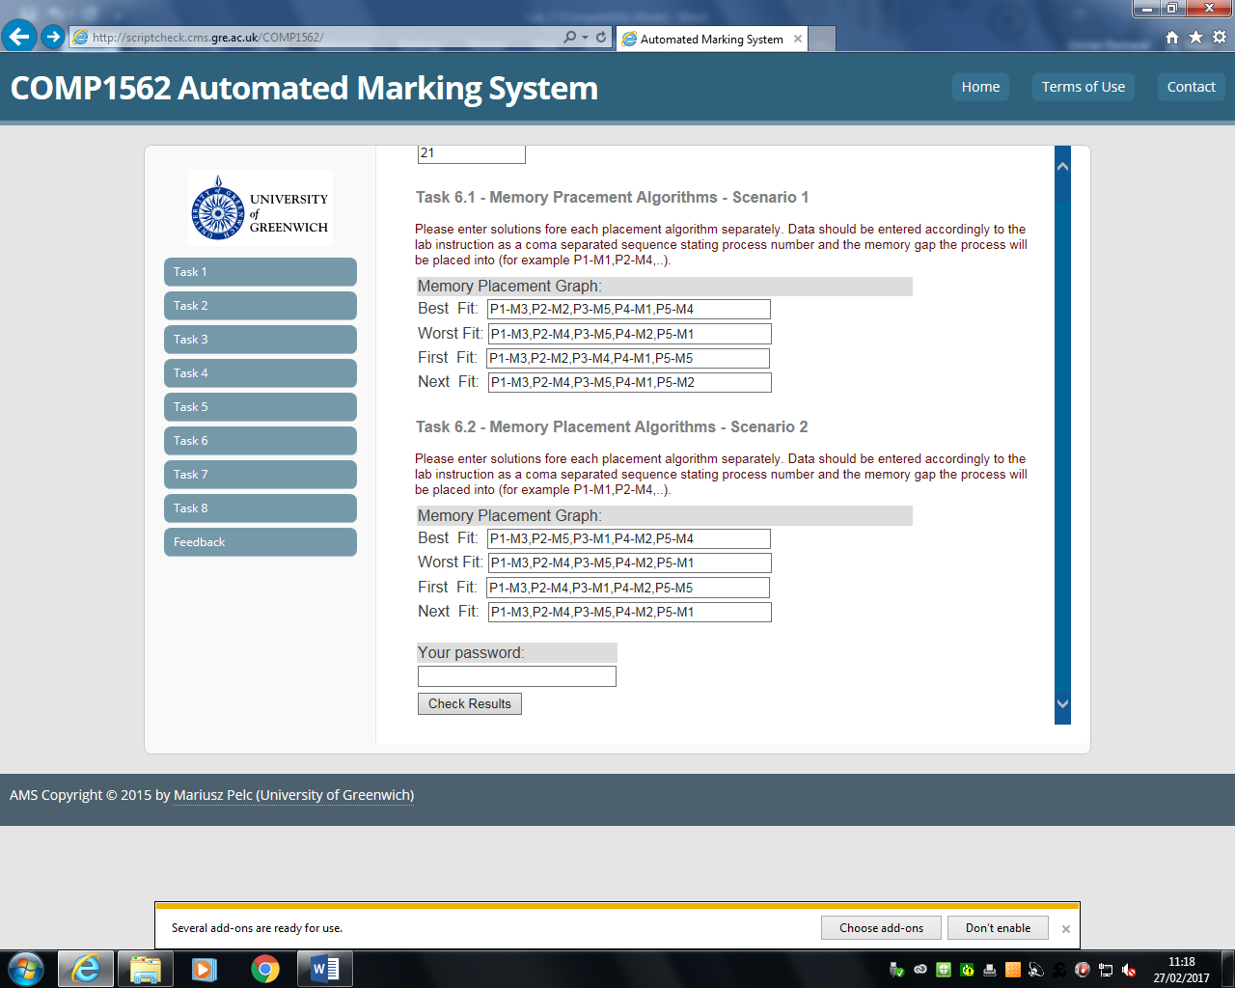

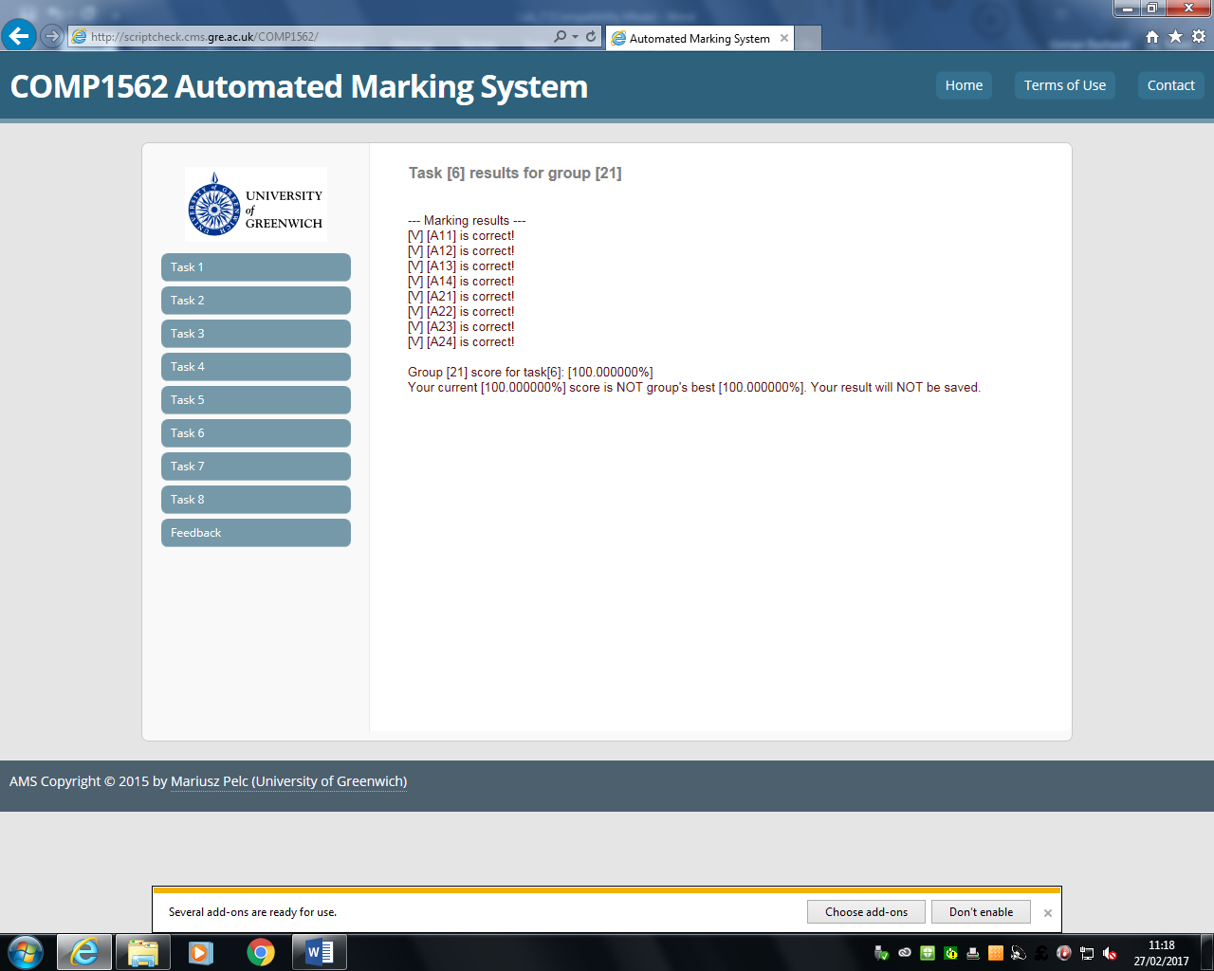

Scriptcheck system will be expecting your solutions to be provided in the following format:

**P1-M3,P2-M4,P3-M1,P4-M2,P5-M5**

meaning that process **P1** goes into memory gap **M3**, **P2** into **M4**, and so on. For the two scenarios above provide solution as to how exactly the processes will be placed for all mentioned memory placement algorithms (**first**, **best**, **next** and **worst**).

Please **DO NOT** add ANY extra spaces in ANY line of your solution. The scriptcheck does script comparison while checking your solutions hence any extra space in your solution line will automatically mean scriptcheck will treat your solution as wrong one. .

**Techniques/resources:**

**Solution of all the above tasks does not require anything except scriptcheck system to enter solutions and calculator to for calculations.**

**Marking:**

**The solutions will be marked in the range 0-100%.**

**Deadline:**

**The solutions should be delivered within one week from the lab date.**